

Course Design

**Report**

**Design Title**：Scholarship Management System

**Department：**Computer Science

**Class：** 2018 Bachelor International Student

**Student Name：**James P. Smith Jr

**Start and end date:** October - December 2021

**Instructor:**

TABLE OF CONTENT

1、 Foreword -------------------------------------------------------------------------------- one

1.1 system development background ---------------------------------------------------- two

1.2 research purpose and significance ----------------------------------------------------- two

1.3 system development tools ---------------------------------------------------------------- two

2、 Functional requirements analysis ----------------------------------------------------- one

2.1 main functions of the system -------------------------------------------------------------- two

2.2 system roles and functions ----------------------------------------------------------------- two

2.3 overall use case diagram of student dormitory management system ------------------- two

2.4 basic system flow ---------------------------------------------------------------------------- three

2.5 use case description of individual responsible module ----------------------------------- five

3、 Overall system design ------------------------------------------------------------------------ nine

3.1 contents of database design: ------------------------------------------------------------------- ten

3.2 system E-R diagram: --------------------------------------------------------------------------- ten

4、 Detailed design ------------------------------------------------------------------------------- eleven

4.1 detailed design of administrator login module --------------------------------------------- eleven

4.2 detailed design of administrator information management module ---------------------- eleven

4.3 detailed design of student information management module ---------------------------- thirteen

4.4 detailed design of dormitory room information management module ----------------- thirteen

5、 Operation results: ----------------------------------------------------------------------------fourteen

5.1 screenshot of operation results -------------------------------------------------------------- fourteen

5.2 test cases ----------------------------------------------------------------------- --------------seenteen

Summary and experience --------------------------------------------------------------------- twenty-one

# 

# Preface

## 1.1 System development background

Access to education in Liberia is considerable challenge, especially in rural and understated communities around the country. According to UNICEF, Liberia has the world’s largest out-of-school children. Learning squared Liberia works with community, women and rural schools to provide practical solutions to that problem and access to quality education and foster economic and social development for women.

The scholarship management system is made under this environment. Through the closed-loop integration of the core elements of the school's resource opportunities, the scholarship management system realizes the the need for better opportunities for quality education thus this project is gear towards providing many Liberians the opportunity to access these educational opportunities around the world and in Liberia at large.

The scholarship management system liberates students as they access these opportunities around the world and in Liberia. It also help many higher education institutions to find better and well deserving students for sponsorship around the world. This project is gear towards the improvement of access to higher education in Liberia and also serve as the gateway between well deserving students and higher learning institutions.

The design of "scholarship management system" adopts php, one of the most popular network programming languages, and the database adopts mysql, which improves the storage security of data. The overall framework of the system adopts content relational structure, which is conducive to the interaction between the system and users. "scholarship management system" The function design basically meets the needs of the practical application of higher learning institutions and the Liberian society

## 1.2、System development tools

**WeChat Mini IDE, Mysql SQLyog Sublime Text Editor**

**WeChat Mini IDE**:

One of the top characteristics of Mini Programs is how light they are. They are limited to 10MB in size. Moreover, the user doesn’t need to download it. This is because it is already integrated into the wechat system. As the hosted on Tencent’s server, Mini Programs are vast offering a great user experience.

These are critical factors for acquiring new users. The fact is that it does not need to be downloaded, invited or more people come to your Mini Program. Even if only one to have a look. Furthermore, the cost of developing a native app is usually higher than the cost to develop an average wechat mini program.

Moreover, Mini Programs are easy to share. Therefore, happy users can quickly become a useful marketing tools in your hand.

**MySQL relational database management system.**

SQLYOG is a fast and concise tool for graphical management of MySQL database. It can effectively manage your database anywhere. It is produced by the famous webyog company in the industry. Using sqlyog, you can quickly and intuitively maintain the remote MySQL database from any corner of the world through the network.

**Sublime Text Editor:**

Sublime text editor is a commercial source code editor. It natively supports many programming languages and markup languages. Users can expand its functionalities with plugins. Sublime text also feature a Python API[1]

**PHP Programming:**

PHP is a scripting languages use for web base applications. It is use to write server side programming and directly interact with MySQL server among many others. It comes with a interpreter that interoperate the code to binary and execute files relating to HTML with HTTP protocol.

# 2 Functional requirements analysis

Under manual conditions, many higher learning institutions carry out survey in order to find well deserving students for scholarships opportunities, due to this, many students find it difficult to reach to the right kind of institution to access these scholarship opportunities.

After the realization of informatization, many well deserving students and higher learning institutions will now be able to access well deserving students and students will be able to access higher educational institutions for the purpose of educational opportunities.

## 2.1 Main functions of the system

The system is based on scholarship opportunities management and provides a scientific and effective management mode. The main function design of the system includes two parts: administrator information management, and scholarship information management.

## 2.2 System roles and functions

**System administrator:** the system administrator can add, query and delete other information after successfully logging in to the system.

**User:** The user can easily review scholarship opportunities and apply for said opportunity easily. The administrator manages the basic information of scholarship, including the addition, modification and deletion of scholarship information.

## system use case diagram2.3 System Use Case

**Fig 1: overall use case diagram**

**Figure 1 overall use case diagram**

The scholarship management system has two roles: administrator, and user. Only the administrator of the whole system has the authority to operate the information of the system. However, the precondition is that the administrator can log in successfully, that is, only the system administrator can simply add, delete, modify and query the system.

## 2.4 System Operating Process

Basic process of scholarship management system:

The system administrator enters the correct account and password to enter the home page of the scholarship management system. After entering the home page, there can be two functional roles, namely scholarship information management and scholarship application information management. The administrator has the right to select one of the two functions for addition, deletion, modification and query. When the execution is completed, it will judge whether the execution is successful. After the execution is successful, you can return to the main page. When all the operations of the administrator are completed, you can exit the system.

**start**

**Admin Enter Login Detail**

**Judge if password is correct**

**Enter Admin Page**

**Select Add Scholarship**

**Manage Requests**

**Edit Data**

**Add Data**

**Delete data**

**Delete Request**

**Manage Request**

**Process Request**

**View Request**

**Judge operation success**

**Manage Data**

**success**

**End**

**Fig. 2 overall system flow chart**

Login of administrator information:

1. Module description

Admin must log in before entering the scholarship management system to realize the legal distribution of admin rights.

2. Function

The user login module can enter two items: admin name and password. When the two items are consistent with those in the database, you can enter the system according to the authority of the entered admin name.

3. Performance

Security and confidentiality

The permissions of admin after login are designed. Login protection is designed. If the admin enters the wrong password, the system will give a prompt of password error. The rest are visual interfaces, and admin can select functions according to the system prompt.

4. Input

(1) admin name: the type is character type and the length is 30 bytes;

(2) Password: the type is character type, with a length of at least 6 bytes and a maximum of 20 bytes;

5. Output item

If the user name and password are correct, you will be prompted that the password is true

If the admin and password are incorrect, you will be prompted that the admin name or password is wrong. Please re-enter

6. Design method

The module is a page that submits the admin name and password through the button. Then connect to the database for verification. To determine whether the admin name and password are true and whether they can enter the system.

7. Interface

Click login and enter the system interface if the password is correct. If the password is wrong, there shall be prompted that the admin name or password is wrong. Please re-enter

8. Test design

Administrator login function:

Requirement Description: the administrator logs in to the account through this part

Performer: Administrator

Precondition: the administrator information is valid and legal, and can only be operated by the administrator. Other roles do not have permission.

Post condition: prompt: login succeeded

Normal process:

1. The administrator enters the correct user name.

2. The administrator enters the correct password.

3. The system calls the administrator information in the database

4. The system displays that the user has logged in successfully

Abnormal process:

1. If the admin does not exist, login is refused and the use case ends.

2. The admin name is correct and the password is wrong. End of use case.

scholarship information update function:

Requirement Description: the administrator logs in to the scholarship management system to update and delete

Performer: Administrator

Precondition: the administrator information is valid and legal, and can only be operated by the administrator.

Post condition: scholarship information updated successfully

Normal process:

1. The system administrator logs into the scholarship management system by entering the correct account and password to enter the main interface of the system.

2. The administrator selects the scholarship information management function module

3. The administrator selects the operation to add scholarship information,

4. admin provide their own correct certification information,

5. scholarship information added successfully

6. The administrator selects the operation to delete the scholarship information

7. scholarship information deleted successfully

8. The administrator selects the operation to modify the scholarship information

9. scholarship information modified successfully

10. The administrator selects the query operation for scholarship information

11. The scholarship information is successfully displayed on the page

12. When the operation is completed, return to the main page.

Abnormal process:

1. The administrator information does not exist and cannot log in to the system. The use case ends.

2. The network is abnormal, unable to log in to the system, and the use case ends.

3. The admin provided wrong information and failed to add scholarship information.

# 3. System Overall Design

## 3.1 Database Design

Relational model is the most widely used and technologically mature database model at present. It is characterized by simple and clear concept, easy to be mastered and accepted by users, strict mathematical basis and relational data theory, which can greatly simplify database development and maintenance, and is deeply welcomed by a wide range of users, It is the foundation and core of modern computer information system and computer application system.

The scholarship management system adopts B / S architecture. Connect the database with the browser. Through the processing of the foreground page, the server operates the target data in the background database through HTTP protocol. After triggering the operation update in the database, it responds the data to the front page, so that the manager can operate and manage the system conveniently. When the administrator updates the information, he submits the information to the background database, and the database saves the data.

# Detailed Design

## 4.1 Module detailed design

The system displays the login interface. The administrator enters his account and password, and the system verifies the user information. If the information is wrong, the system displays the wrong information, please re-enter the user name or password. The administrator successfully logs in to the login.php of the scholarship management system by entering the correct website in the browser, enters his own account and password, sends a request to the front end of this page, connects to the database, loads the driver, executes the administrator login program, and then transmits the operation results of the database to the front page to enter the index.php main page.

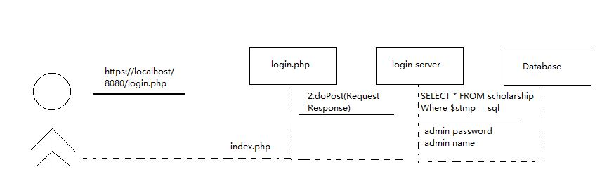Login sequence diagram:

**Fig 3: Detail Design**

## 4.2 Module detailed design

The administrator successfully logs into the login page of the scholarship management system by entering the correct website in the browser. After logging in, the administrator jumps to the index.php admin page, where the front end sends a request. The system calls the adminiinfo class to connect the database, load the driver, execute the SQL statement of the query administrator, and then transfer the operation results of the database to the front page, Enter the index.php page.



Admin Details

**Fig 4: Sequence diagram of administrator information query:**

**Figure 4 sequence diagram of administrator information query**

Administrator information registration sequence diagram: The administrator successfully logs in to the login page of the scholarship management system by entering the correct website in the browser. After logging in, the administrator jumps to the index.php admin page, where the front end sends a request and executes the SQL statement. Then transfer the database operation results to the foreground page and enter the index.php page.

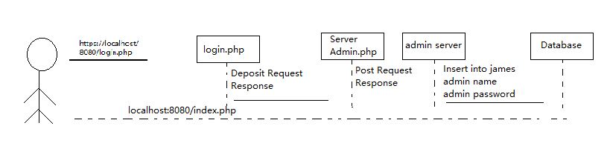

**Fig 5: Sequence Diagram Administrator registration**

sequence diagram of administrator information registration

Administrator information deletion sequence diagram:

The administrator successfully logs in to the login page of the scholarship management system by entering the correct website in the browser. After logging in, the administrator jumps to the index.php admin page, where the front end sends a request. The system connects to the background database, loads the driver, executes the SQL statement to update scholarship information.

## 4.3 Module detailed design

This is the sequence diagram of the management operation case of the scholarship information by the administrator of the scholarship management system, specifically the addition and deletion of the scholarship information. The administrator first logs in the scholarship management interface to view the scholarship details, and then can choose to delete or add the scholarship information, such as deleting the scholarship information, After completing the operation, return to the scholarship management interface. Select Add reservation information, and the system will enter the added information. After completing the above operations, return to the main interface. After logging into the main page, the administrator needs to select the operation type of adding or deleting scholarship information. Then the administrator needs to enter the password to carry out the next operation on the system. If the password is wrong, it will stay in the current interface. After entering the password successfully, the admin information can be added or deleted.



**Figure 6: Sequence diagram of scholarship information management module.**

# Running Result

The administrator enters the login page of the scholarship management system. The administrator enters the correct account and password, but there is no administrator registration function in the login admin page. Therefore, only administrators in the system database can log in.

ADD LOGIN PAGE SCREENSHOT

**Figure 6: Login Page Design**

As shown in Figure 6: after the administrator successfully logs in the system, enter the system admin page. The page mainly displays the basic information of the logged in administrator and four functional modules

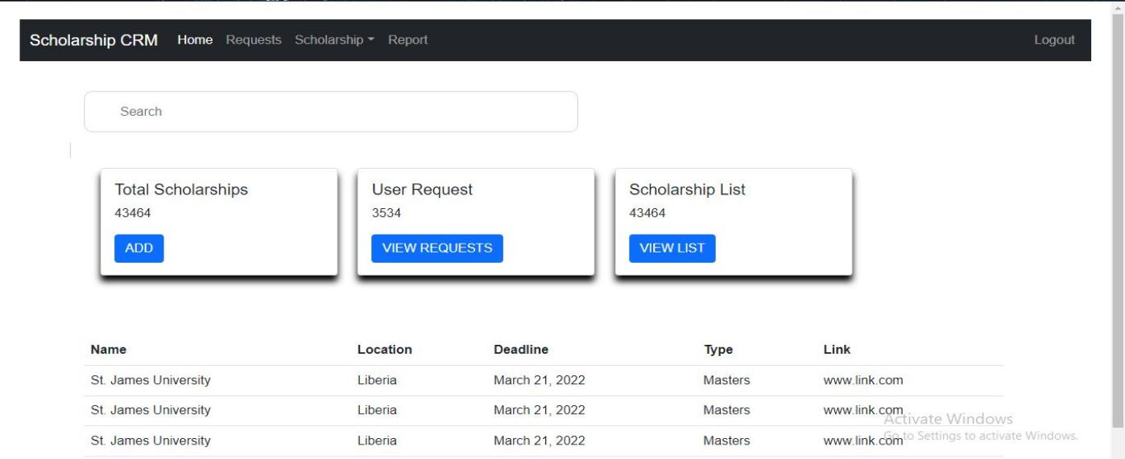

图 13

**Figure 7: Admin Dashboard**

**Figure 7: Admin Dashboard**

After the above steps are completed, the administrator selects the Add Scholarship information management module and enters the page shown in the figure below. First, the list of scholarships information are displayed. On this page, you can select the operations of querying, adding, modifying and deleting scholarship information. After the operation is completed, you can return to the admin page.

**Figure 7: Admin Dashboard**

After the above steps are completed, the administrator selects the scholarship information management module. The scholarship management mainly includes the query of scholarship information, the addition of scholarship and scholarship information. After the operation is completed, return to the system admin page.

## 

## 5.2 Test Case

Administrator login test process:

Enter user name: admin, enter password: 11111

The system outputs after verification. The admin password is wrong. Please re-enter it;

Re enter the password: admin. After entering the system, the system will give the system administrator and user interface;

**Table 1: Administrator login test case:**

|  |  |  |  |  |
| --- | --- | --- | --- | --- |
| code | operation | Inspection point | Expected results | Actual results |
| Test_1 | Do not enter any information  Click login | 1. Confirmation function  2. Confirmation prompt  3. Result display | Unable to log on to the system  Display warning message | Unable to log in  Display account password error |
| Test_2 | Enter a admin name that exists and a password that does not exist | 1. Confirmation function  2. Confirmation prompt  3. Result display | Unable to log on to the system  "Please enter the correct password" is displayed | Unable to log in  Display account password error |
| Test_3 | Enter a admin name that does not exist and a password that does not exist | 1. Confirmation function  2. Confirmation prompt  3. Result display | Unable to log on to the system  The system displays "admin name does not exist" | Unable to log in  Display account password error |
| Test_4 | Enter the existing admin name and password | 1. Confirmation function  2. Confirmation prompt  3. Result display | Log in successfully, and the login success interface is displayed | Log in successfully, and the login success interface is displayed |

Administrator information management test case:

The administrator enters the admin name and password through the existing account to log in to the scholarship management system. After successful login, select the scholarship information function module on the main page to view, add, modify and delete scholarship information.

**Table 2: Test case of student information update module:**

|  |  |  |  |  |  |
| --- | --- | --- | --- | --- | --- |
| testing procedure | pedagogicaoperation | input | Expected output | Actual output | Pass or not |
| Test-_1 | 1. Log in to the system first | 1：admin  2：admin 1. Account No.: admin  2. Password: admin | Jump to system main interface | Jump to system main interface | yes |
| Test-_2 | 2.Click scholarship information |  | Jump to add scholarship screen | Jump to scholarship screen | yes |
| Test-_3 | 3.Click add scholarship information and submit | 1. Name  2.address  3.eligiblity  4. link | Jump to scholarship information page | Jump to student information page | no |

**Table 3:Scholarship information test case:**

|  |  |  |  |  |  |
| --- | --- | --- | --- | --- | --- |
| step | pedagogical operation | input | Expected output | Actual output | Pass or not |
| Test_1 | 1. Log in to the background first  2.Click scholarship management  3. Click add scholarship |  | Jump to the interface of adding scholarship details | Jump to the interface of adding scholarship details | Yes |
| Test_2 | 1. Log in to the background first  2. Click scholarship management  3. Click add scholarship  4. Click the submit button | admin  2.admin  1. Administrator account: admin  2. Password: admin | 1. Prompt that the scholarship is added successfully  2. Automatically jump to the system scholarship information management interface | scholarship information management interface | no |
| Test_3 | 1. Log in to the background first  2. Click scholarship information management  3. Click view records |  |  | View scholarship record succeeded | no |

The administrator enters the admin name and password through the existing account to log in to the scholarship management system. After successful login, select the scholarship information function module on the main page to view, add and view scholarship information.

# Summary and Experience

LOOK AT THIS SAMPLE BELOW AND WRITE THE SUMMARY PLEASE, I WANT TO BE WORKING ON THE OTHER ASPECTS. SO FAR THIS IS THE FINAL PART OF THE PAPER. WHEN YOU DONE JUST LET ME KNOW SO WE CAN EDIT IT TOGETHER.

The whole design of this course design has passed the debugging of software and hardware. I think it will be of great help to my future study and work. Many practical problems have been encountered in this design. In the actual design, it is found that there is still a certain difference between the theoretical things in books and those in practical application. Therefore, some problems should not only be deeply understood, but also constantly correct the previous wrong thinking. All problems must be solved by yourself bit by bit, and in the process of solving, you will find yourself improving rapidly. For the textbook management system, its program is relatively simple, mainly to solve the problems in program design, and program design is a very flexible thing. It reflects your logical thinking and innovation ability to solve problems, and it is the soul of a design. Therefore, most of the time is spent on the program in the whole design process. Many subroutines can be learned from books, but how to connect each subroutine is the key problem, which needs to be familiar with the structure of the system. Therefore, it can be said that the design of the system is the combination of software and hardware, which are inseparable. Through this course design, I also found my own shortcomings. Although I feel that I have mastered the theory, there are still unexpected puzzles in the process of application to practice, which can be solved after some efforts.

This has also stimulated my interest in studying hard in the future. I think it will have a positive impact on my future study. Secondly, this course design makes me fully realize the importance of teamwork. Only Division of labor and cooperation can ensure the orderly operation of the whole project. In addition, in the process of curriculum design, when we encounter problems we don't understand, the instructor always explains patiently, which is of great help to our design and makes us benefit a lot. So thank you very much for your teaching. Through this design, I understand the importance of learning, understand the significance of the combination of theoretical knowledge and practice, and learn to insist, be patient and work hard, which will set the best example for my future study and work. I think as a student majoring in software engineering, this course design is very meaningful. More importantly, how to apply what they usually learn to practice. Although I don't know much about this course, and I don't have a good grasp of many basic things. I think it's difficult and there is no effective way to understand it by myself, I gradually have some interest in this course with the help and explanation of group students after more than a week of "learning", I began to take the initiative to learn and gradually began to understand it from the foundation.

I think the harvest should be considerable. At the beginning, we found the subject from the reference books, but it was a reference book after all. Later, we found that many programs were incomplete, which made us break our brains. It seems that other groups have made a model, but we haven't even decided on a subject. I finally found the subject again, but the result is still very unsatisfactory. The connection between programs is done, and there is no problem in debugging, but it just can't achieve the desired results. After all, a reference book is only a reference. In the end, you have to use your own brains to design this kind of thing. Then we all worked together and finally completed the experiment we usually did, the examples given by the teacher in class, the knowledge in books, the teacher's guidance and the help of other students. It should be said that this was accomplished through the joint efforts and brains of our team members. Although the content is not very complex, we think the design process is very important, learned a lot and gained a lot. Curriculum design reflects a process from theory to practical application, but it can be further related to a process from school to society after graduation. The cooperation and coexistence of team members, as well as their own brain and efforts, are needed in future work.

Therefore, this course design is of great help to each of us. The process of learning, cooperation and efforts with other students is also very pleasant. In addition, we should also thank the teacher for his good intentions.